MEASURE ENERGY CONSUMPTION

TEAM MEMBER

510521205055 : VIJAY.G

PHASE 2 : DOCUMENT SUBMISSION

Data WRANGLING TECHNIQUES



OBJECTIVES:

Data wrangling is a crucial step in the process of measuring energy consumption, as it involves preparing and cleaning raw data to make it suitable for analysis. Here are some data wrangling techniques that can be applied in the context of measuring energy consumption.

Data Collection:

Collect data from various sources, including sensors, meters, and databases.

Ensure data is timestamped accurately to capture temporal patterns.

Data Cleaning:

Handle missing data by imputing values, interpolating, or removing incomplete records.

Identify and handle outliers that may result from sensor malfunctions or unusual energy consumption events.

Data Validation:

Check for data integrity issues, such as duplicate records or inconsistent data formats.

Validate data against expected ranges or thresholds to identify erroneous readings.

Data Aggregation:

Aggregate data at appropriate time intervals (e.g., hourly, daily, monthly) to match the analysis requirements.

Summarize data for different energy sources (e.g., electricity, gas, water) separately.

Data Transformation:

Convert energy units if data is recorded in different units (e.g., kWh to MWh).

Normalize data if necessary, for example, by adjusting for factors like temperature or occupancy.

DATA WRANGLING PROCESS:

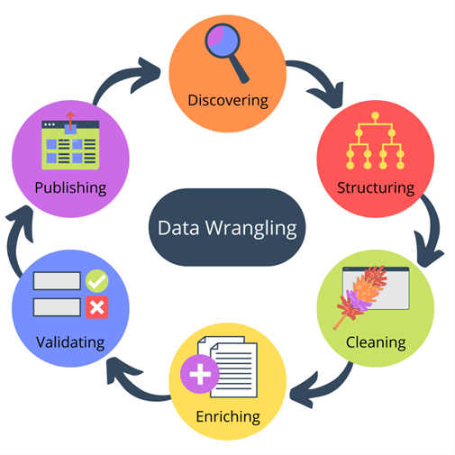

Feature Engineering:

Create additional features that may enhance analysis, such as rolling averages, moving sums, or lagged variables.

Calculate energy intensity metrics (e.g., energy per square foot) for benchmarking.

Data Integration:

Merge data from different sources, such as weather data, building occupancy data, or equipment maintenance logs, to enrich the energy consumption dataset.

Data Quality Assurance:

Establish data quality checks and validation rules to continuously monitor data quality over time.

Data Visualization:

Create visualizations to explore and understand data patterns, trends, and anomalies.

Use visualization tools like line charts, heatmaps, and scatter plots to uncover insights.

Data Storage:

Store cleaned and preprocessed data in a structured format, such as a relational database or a data warehouse, for efficient retrieval and analysis.

Data Security:

Implement security measures to protect sensitive energy consumption data from unauthorized access or breaches.

Documentation:

Maintain thorough documentation of data wrangling steps, transformation processes, and data sources for reproducibility and auditability.

Data wrangling is an iterative process, and the specific techniques and tools used may vary depending on the complexity of the energy consumption data and the goals of the analysis. Python libraries like pandas, NumPy, and matplotlib can be valuable for implementing these data wrangling techniques, along with specialized tools for time series analysis and data visualization.

Introduction to neural network :

Neural networks are computational models inspired by the structure and functioning of the human brain. They consist of interconnected nodes, called neurons or artificial neurons, organized in layers. Each connection between neurons has a weight associated with it, which determines the strength of the connection.

Neural networks can learn from data by adjusting these weights to make predictions or classifications based on input information.

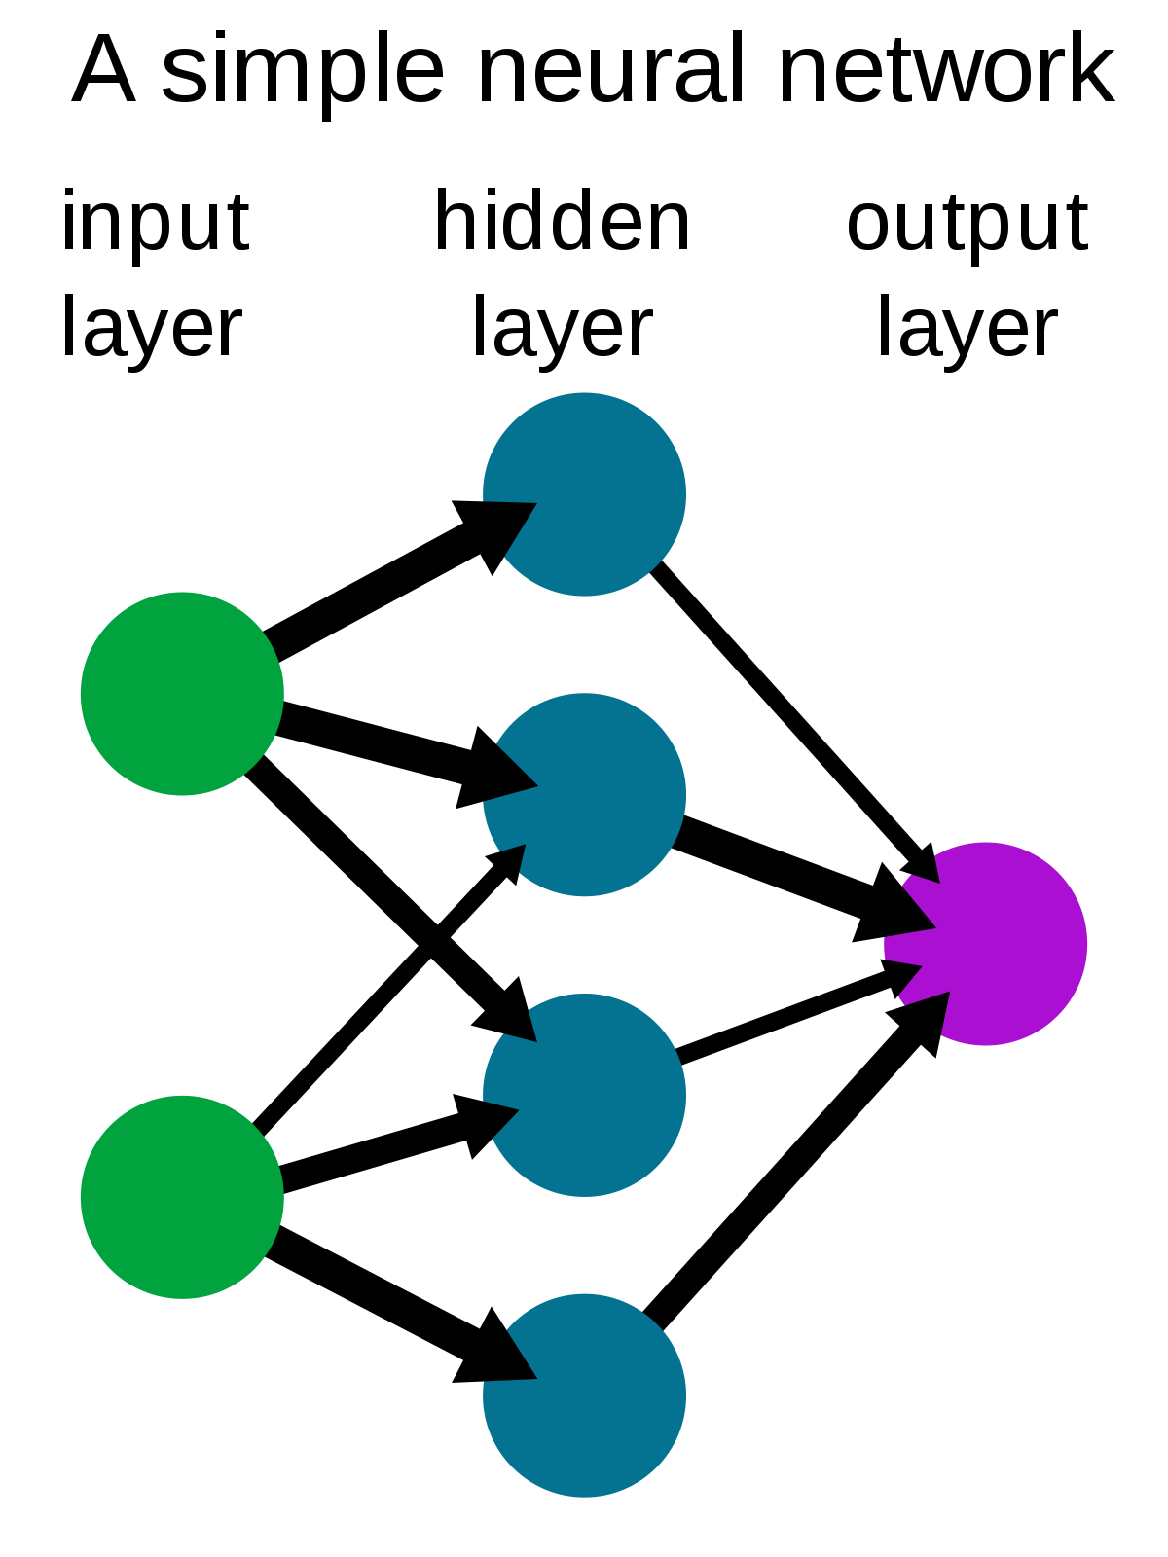

Importance of Measuring Energy Consumption:

Accurate energy consumption measurement is crucial for various reasons.

Cost Reduction: Precise measurement helps identify areas of inefficiency, allowing for cost savings through optimization.

Environmental Impact: Reducing energy consumption can minimize carbon emissions and environmental harm.

Resource Management: Efficient energy use ensures the sustainable use of finite resources.

Regulatory Compliance: Many industries are subject to energy consumption regulations and standards.

Neural Networks in Energy Consumption Measurement:

Neural networks can be applied to measure energy consumption in several ways.

* Predictive Modeling: Neural networks can be trained on historical energy consumption data to predict future energy usage. This is particularly useful for demand forecasting in utilities and industries, allowing for better resource planning.
* Anomaly Detection: Neural networks can detect abnormal energy consumption patterns, which may indicate equipment malfunctions, leaks, or security breaches. This helps prevent energy wastage and potential hazards.
* Optimization: Neural networks can be used to optimize energy consumption by recommending changes in usage patterns or control strategies. This can lead to energy and cost savings.
* Real-time Monitoring: In IoT (Internet of Things) applications, neural networks can process data from sensors and devices in real time to monitor and control energy consumption.

Data Requirements:

To train neural networks effectively for energy consumption measurement, large and high-quality datasets are essential. These datasets should include historical energy consumption records, weather data, operational parameters, and any other relevant information.

Benefits of Neural Networks:

Flexibility: Neural networks can handle complex, nonlinear relationships in data, making them suitable for diverse energy consumption scenarios.

Continuous Learning: They can adapt to changing conditions and improve accuracy over time as they receive more data.

Automation: Neural networks can perform tasks automatically, reducing the need for manual monitoring and analysis.

Challenges and Considerations:

Data Quality: High-quality data is crucial for neural network performance.

Model Complexity: Choosing the right architecture and hyperparameters is essential.

Interpretability: Neural networks can be considered "black boxes," making it challenging to explain their decisions.

Conclusion:

neural networks offer a powerful approach to measuring energy consumption accurately, predicting future usage, and optimizing energy management. As technology continues to advance, their role in energy conservation and sustainability efforts is likely to become increasingly significant. However, it's essential to approach their implementation with a clear understanding of data requirements, model complexities, and interpretability considerations to reap the full benefits of this technology.

neural networks for measuring energy consumption presents a promising and effective approach in various applications, including energy management, conservation, and sustainability efforts. Neural networks have demonstrated their ability to capture complex relationships within energy data, enabling accurate predictions and real-time monitoring.

Precision: Neural networks can model intricate patterns and dependencies in energy data, leading to highly accurate predictions and insights.

Flexibility: They can adapt to changing conditions and accommodate various data sources, making them suitable for a wide range of energy monitoring tasks.

Real-time Monitoring: Neural networks can provide real-time feedback on energy usage, allowing for proactive adjustments and optimization of energy consumption.

Cost Reduction: By identifying inefficiencies and anomalies in energy usage, neural networks can help organizations reduce energy costs and improve resource allocation.

Environmental Impact: Accurate energy consumption measurement is critical for sustainability efforts, and neural networks can contribute to reducing carbon footprints and promoting eco-friendly practices.

However, it is essential to acknowledge some challenges and considerations when implementing neural networks for energy consumption measurement:

Data Quality: Reliable and high-quality data is crucial for the success of neural network models. Inaccurate or incomplete data can lead to erroneous predictions.

Model Complexity: Complex neural network architectures may require significant computational resources and expertise for training and deployment.

Interpretability: The inner workings of neural networks can be challenging to interpret, which may raise concerns regarding model transparency and accountability.

Security: Ensuring the security of energy consumption data and neural network models is paramount to protect against potential cyber threats.

In conclusion, neural networks offer a powerful tool for measuring energy consumption, offering the potential for increased energy efficiency and sustainability. To maximize their benefits, organizations should carefully consider data quality, model complexity, interpretability, and security while harnessing the capabilities of neural networks in energy management and conservation efforts. As technology continues to advance, neural networks are likely to play an increasingly vital role in shaping a more sustainable and energy-efficient future.